The commissioning progress of microwave imaging reflectometer on EAST tokamak

Lifu ZHANG,a Jinuo Yu,a Jinchen Yang,a Ge Zhuanga and Jinlin XIE a,1

1. Department of Plasma Physics and Fusion Engineering, USTC,  
   Hefei, China

*E-mail*: jlxie@ustc.edu.cn

Abstract: The two-dimensional mm-wave imaging reflectometer (MIR) is an attractive diagnostics system for visualization of density fluctuations in fusion plasmas. The 96-channel EAST MIR system (12 poloidal ╳ 8 radial) operates in a frerquency range of 75 to 110 GHz. The innovative optical design provides adjustable wavefront, poloidal, and radial observation ranges. The output power of MIR illumination system is increased to optimize the Signal-Noise-Ratio. The MIR frequency setting is carefully chose to avoid crosstalking issue. Via the carefully designed bench-top experiments, the minimum required SNR is verified for EAST MIR. With single radial and multiple poloidal set-up, coherent modes have been observed in EAST plasmas via MIR.

Keywords: Density fluctuation; Microwave reflectometry; Space echo.

Contents

1. Introduction 1

2. Plasma accessibility 2

3. MIR Hardware 3

3.1 Upgrade of RF system 3

3.2 MIR Electronics 4

3.3 Optical components 6

4. The chopper experiment 7

4.1 The quality of the MIR raw data 7

4.2 The diagram of the chopper experiment. 7

4.3 Results of the chopper experiment. 8

5. Preliminary experimental results of the MIR system on EAST. 10

6. Summary 12

1. Introduction

Active microwave reflectometry is commonly employed for both electron density profile and fluctuation measurements [1-2]. The cutoff layer is usually assumed to be an ideal flat surface for reflection, which ensures a neat interpretation of the diagnostic data. For instance, the density fluctuation level is proportional to the phase variation level. However, the assumption is questionable in real case considering the 2-D density fluctuations (both in the radial and in the poloidal direction) developed on cutoff layer with different spatial scales. Consequently, the perturbed cutoff layer would act like a diffraction grating and the reflected wave scatters over a large solid angle. Since the distance between the cutoff layer and the receiver is usually much larger than the “diffraction distance”, the possible resulted interference will make it difficult to interpret data. Thus a Gaussian optical collecting system with large-aperture is proposed to help reconstruct the correct wavefront at the receiver location [3-4], which re-assure the clean and simple data interpretation. With the aid of large-aperture optical collecting system, it is nature to replace the single detector with 1-D detector array and increase the number of probe beams with different incident frequencies, which realize the microwave imaging reflectometry (MIR) diagnostic system. With the capability to visualize the 2-D density fluctuations in the small cross-section in Tokamks and Stellarators, MIR has been developed in TEXTOR [5], DIII-D [6], WEST [7], KSTAR [8], LHD [9] and HL-2A [10]. However, the actual performance of these systems is far from satisfactory, compared with the tremendous success of another turbulent visulization diagnostics, electron cyclotron emission imaging (ECEI). The published images of 2-D density fluctuations are very limited.

MIR has also been developed for EAST tokamak [11] and laboratory characterization has been given [12]. Fig.1 depicts the installation layout of 2-D microwave imaging reflectometry (MIR) diagnostic system on EAST, together with ECEI co-located on the same port. First, an extended region of the plasma is illuminated with a combined microwave beam with multiple frequencies, each frequency corresponds to a specific cutoff layer. The transmitting optics transforms the curvature of the illuminating wavefront to roughly match the poloidal shape of the plasma cutoff layer. The wavefront curvature matching ensures a nearly constant phase front projected on the fluctuating cut-off layer so that it can be approximated as normal incidence, thereby ensuring that a sufficient fraction of the reflecting electromagnetic power will be coupled back for detection. The reflected beam goes back through plasma and is collected by collection optics with specific optics utilized to image the curved cut-off layer onto the mini-lens detector array. A beam splitter is used to separate the illumination waves from the reflected signals. The spatial structure of the density fluctuation near the cutoff layer is determined by the reconstruction of the reflected wavefront at the image plane, thereby restoring the integrity of the phase measurement [13].

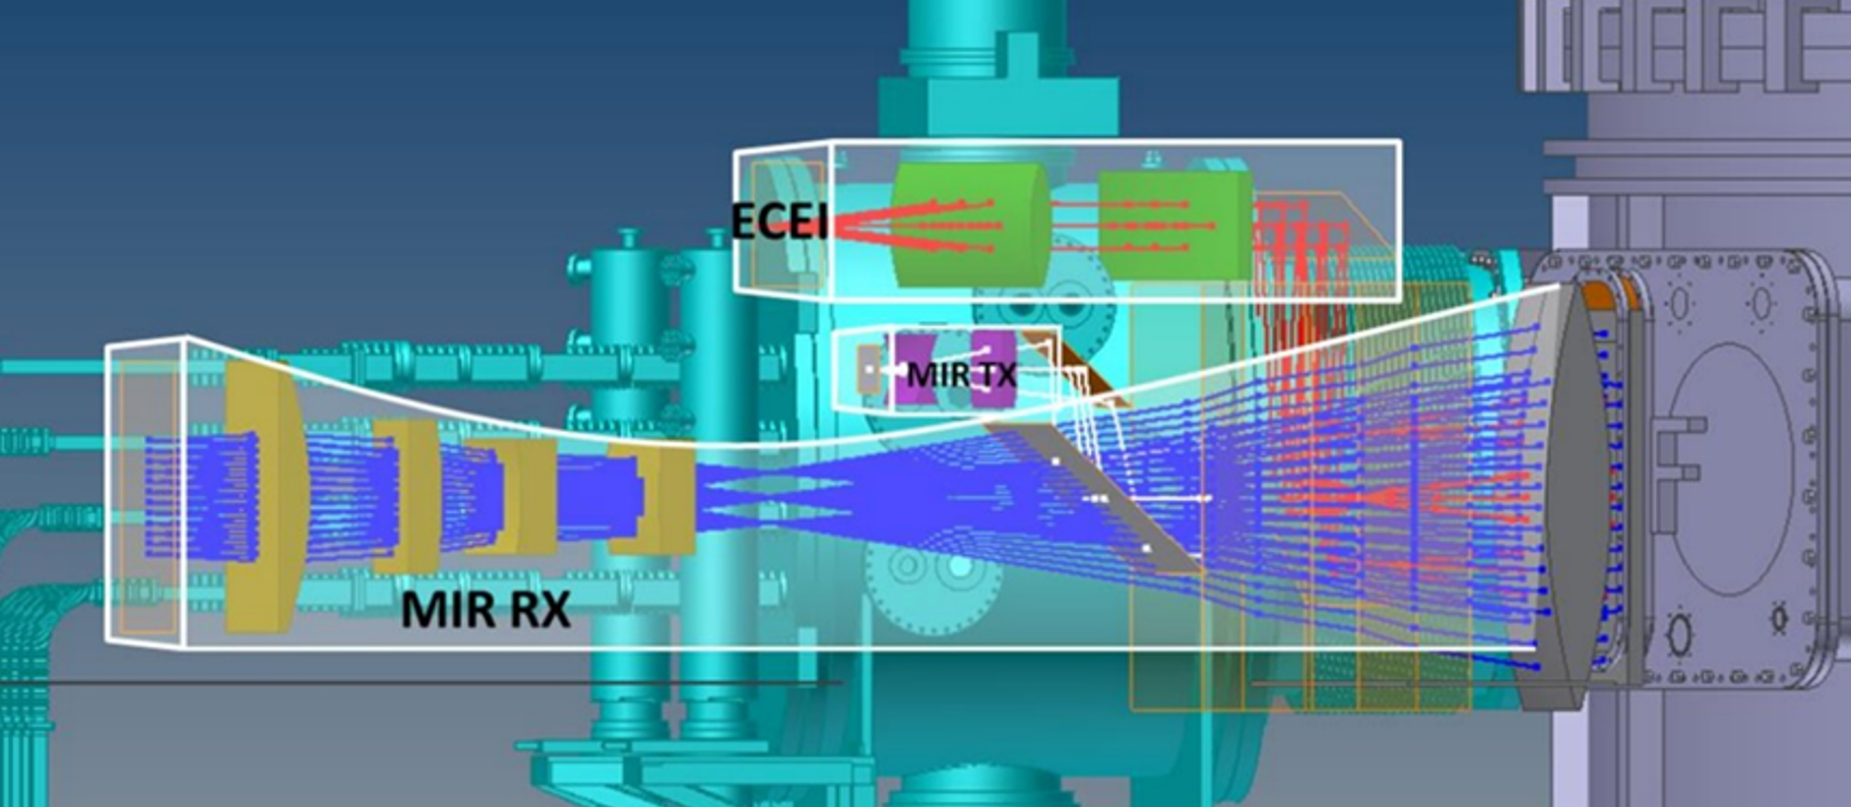

**Figure 1.** Schematic of a 2-D MIR diagnostic system on EAST.

This paper provides an overview of the hardware aspects and difficulties encountered during the EAST MIR implementation. Section II is a discussion of the fundamental constraint on MIR: accessibility in MIR plasmas. The optical and electronics hardwares of the system are discussed in Sec. III., including upgrading of the RF system, the tuning range of the optical parameters and solutions to electronic signal crosstalk. In Sec. IV, chopper experiments are presented to verify the signal-to-noise ratio (SNR) threshold required for correct phase information extraction. The results show that phase information cannot be extracted with SNR below 1.97. Finally, Sec. V gives current status of EAST MIR.

1. Plasma accessibility

Based on the typical discharge parameters of the EAST device, the radial distribution of plasma characteristic frequencies with a toroidal magnetic field around 2.3T is shown in Figure 2. The illumination electromagnetic waves of the EAST MIR system are launched from the low-field side window. The selection of wave frequency must satisfy two conditions: 1) The electromagnetic waves should be reflected by the plasma cutoff layer; 2) The electromagnetic waves should not undergo resonance absorption in the plasma. Thus W-band (75–110 GHz) and X-mode are selected for the incidence wave, which provide a wide radial observation range, as indicated by the green interval in Figure 2.

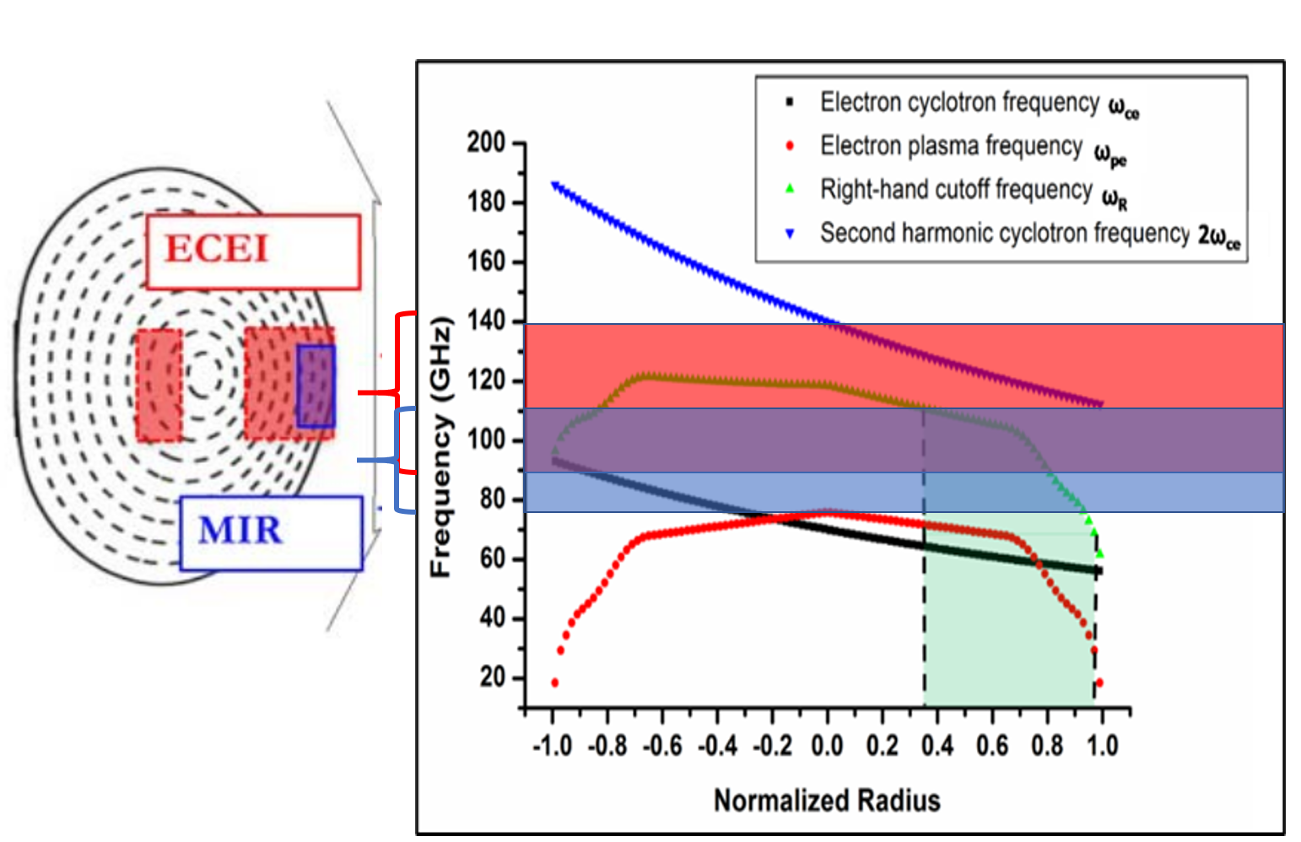

**Figure 2.** the operation frequency ranges of ECEI (red) and MIR (blue) in EAST tokamak.

1. MIR Hardware
   1. Upgrade of RF system

The illumination source in MIR system is similar to the "flash" of a camera, where the illumination signal strength directly affects the quality of the final received signal. In EAST MIR system，eight independent digital synthesis sources provide fundamental frequency signals in the range of 0.65 GHz to 20 GHz. After passing through attenuator with 15 dB attenuation, the signals are then processed by frequency sextuplers. Finally, eight signals are combined through a combiner and launched via a W-band horn antenna.

The previous illumination source provided a maximum output power of only around +3 dBm. Additionally, the coaxial cables were aging, and the devices were not well insulated from the chassis. Furthermore, the layout of the electronic components and power supply cables was suboptimal, which was not conducive to quick maintenance and heat dissipation.

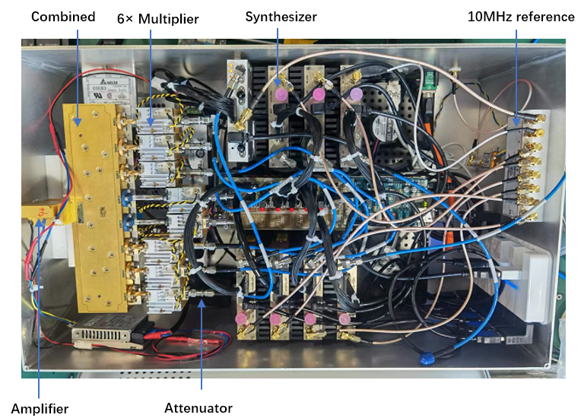The upgraded illumination source is shown in Figure 3. A wideband amplifier with a maximum gain of 18 dBm is positioned at the front end of the Combined unit, significantly increasing the output power of the illumination source. Meanwhile, the re-designed internal housing and optimized power supply system complement each other, providing solid support for the stable operation of the amplifier. The clock power splitter is fixed to the housing using a 3D-printed resin isolation plate, achieving electrical isolation between the electronic components and the metal chassis. The wiring ports of the eight synthesis sources are arranged upward, which improves maintenance efficiency. The internal airflow design has been optimized, further improving the heat dissipation efficiency. The power wiring, adapters, switch power supplies, and other components are neatly arranged, which helps ensure the stable operation of the internal electronic components.

**Figure 3.** The upgraded illumination source.

* 1. MIR Electronics

Figure 4 shows the schematic of EAST MIR electronics. Twelve wideband polar antennas simultaneously receive the reflected signal and local oscillator(LO) signal provided by the antenna's local oscillator source. After mixing with Schottky diodes, the first down-conversion of the reflected signals are generated, reducing the signal frequency range from 75-105 GHz to 2-18 GHz. The mixed signals from the antenna array are then transmitted through twelve RF cables to the corresponding intermediate frequency(IF) electronic modules, where the phase extraction of eight frequency points for each specific receiving antenna is performed. The IF local oscillator sources provide the LO signals for the second down-conversion (frequency range: 0-12 GHz). The eight LO frequency points are set according to the eight frequency points generated by the first down-conversion, and once set, they are provided to each IF module. In the IF module, the down-converted signal from the antenna mixing process is divided into eight branches by a power divider, and each path undergoes a second mixing with a certain IF LO signal. The signal then is filtered through a bandpass filter with a bandwidth of 140±50 MHz, before entering the I/Q phase detector for phase extraction. An external clock source provides 10 MHz synchronization signal for the phase locking of all frequency sources of the MIR system, also the clock signal passing through a 14-times frequency multiplier is provided as 140 MHz LO signal for the I/Q phase detector.

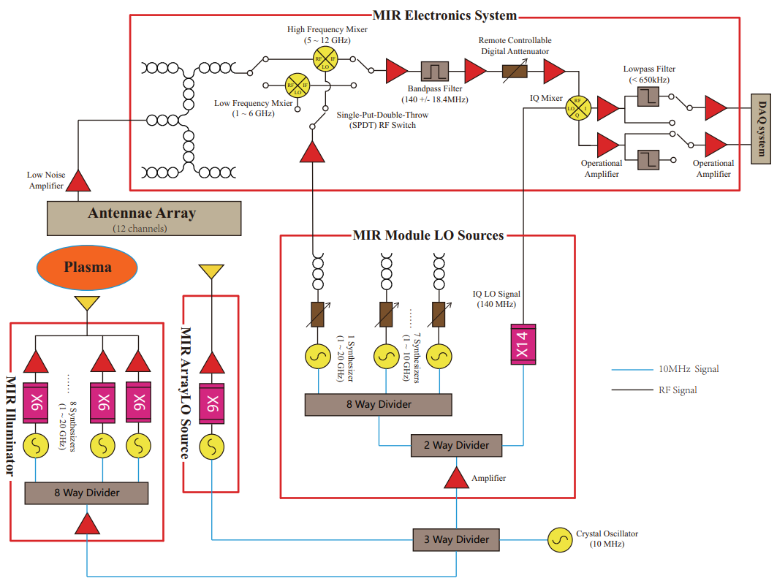

**Figure 4.** EAST MIR System Hardware Architecture.

During laboratory bench testing, it was found that when only one IF LO source signal is active and the other LO channels are disconnected, mixing signals appeared not only in the expected target channel but also in the output ports of channels without IF input. It is verified that signal crosstalk in the IF module primarily occurs along the path where the module's LO signal enters the IF electronic chassis. The site for amplifying and splitting the IF LO signals is located on the IF chassis backplane. The closely packed microstrip circuit boards in limited space result in spatial coupling of different LO signals.

It is difficult to completely resolve crosstalk from a hardware perspective. The IF LO frequencies should be carefully choose to generate differently carrier frequencies for eight corresponding radial positions. The carrier frequencies should be set to ensure that each radial channel has a unique and deterministic relationship with its carrier frequency. By applying corresponding bandpass filtering to the sampled data, it can ensure that the phase signals originate from a specific cutoff layer position, thereby significantly relieving the crosstalk issue.

* 1. Optical components

The optical system of the EAST MIR system include illumination part and receiving part, as shown in Figure 5. To obtain accurate and reliable density fluctuation information, both optical parts must have certain optical parameter adjustment capabilities to realize the coupling and matching of the wavefronts of the illumination beam, the "image plane" of the antenna array and the shape of the cutoff layer.

**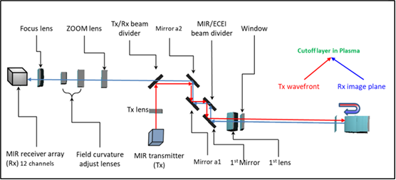****Figure 5.** Schematic diagram of MIR receiving optics and illumination optics.

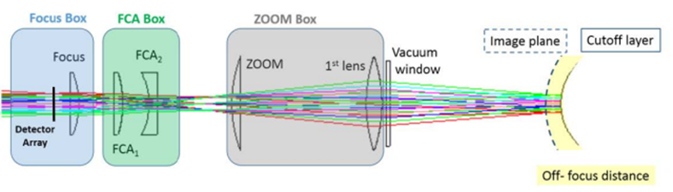The radial observation range of the illumination optics is from 110 mm to 160 mm, and the wavefront curvature radius of incident beam is adjustable within the range of 640 mm to 1560 mm. The EAST MIR receiving optics consists of five high-density polyethylene (HDPE) lenses and two flat mirrors, as shown in Figure 6. The signal reflected from the cutoff layer is received by the ZOOM lens and then sequentially passes through FCA2, FCA1, and the FOCUS lens, ultimately reaching the antenna array [14].

**Figure 6.** Schematic Diagram of the Composition of the Reception Optical Path Lenses.

By adjusting the positions of the lenses, the system allows independent tuning of the focal position on the image plane, the radial observation range and the wavefront curvature of the "image plane." This setup enables the EAST plasma system to achieve a radial observation range of 50 mm to 400 mm, wavefront curvature changes from 570 mm to 850 mm. Correspondingly, the radial resolution can be adjusted within a range of 18.8 mm to 30.8 mm.

1. The chopper experiment
   1. The quality of the MIR raw data

We referred to the operational data of the MIR system from the DIII-D tokamak. Taking DIII-D shot 157102 as an example, signal amplitude varies between 20 mV and 100 mV during the discharge while signal amplitude drops to around 9 mV to 20 mV without discharge, shown in Figure 7(a). The amplitude ratio before and after the discharge is approximately 10:1. Figure 8(b) shows the raw signals collected by EAST MIR system when the optical path was not well-aligned. It was observed that there was almost no change in the envelope before and after the discharge, which suggests that EAST MIR did not the match condition and most of the reflected signals did not collected by the receiving optics in this case. It is found that the evolution of raw data provide direct clues to calibrate the optics and optimize the MIR performance. It is also noticed that the background noise level of EAST MIR in this case is relatively high. Besides the noise from electronic system, the signals reflected back from any unintended surfaces in the optical path also contribute to the background noise, which we call as “space echo”. Unlike the desired MIR signal, the phase delays of space echoes are fixed, they will not change during the discharge,

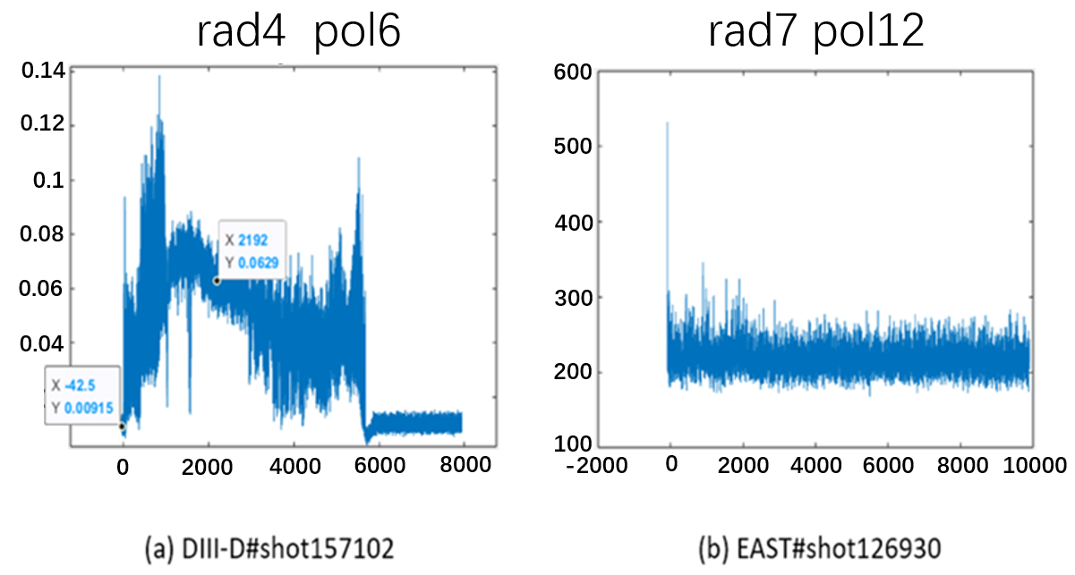

**Figure 7.** Comparison of raw data between DIII-D and EAST.

* 1. The diagram of the chopper experiment.

In order to find out how the space echo will distort the MIR raw data, we set up a chopper experiment in lab. The chopper experiment is shown in Figure 8 and 9. The chopper plate made of high-density polyethylene (HDPE) is placed at the exit of the illumination source's emission horn. By rotating the chopper plate, periodic variations of the optical length are introduced, simulating the phase changes caused by density disturbances in the cutoff layer.

To introduce an additional fix phase difference at the receiving antenna and simulate the interference from space echo signals, a W-band waveguide power divider is added at the emission end of the illumination source. The electromagnetic wave emitted from the upper waveguide horn pass through the chopper plate before entering the antenna, while the other electromagnetic wave from the lower waveguide horn is directly received by the antenna without modulation. By changing the height of the moveable platform, we can change the relative positions of the two horns to the antenna, thus the amplitude ratio of the desired MIR signal to the space echo can be varied. This allows us to verify and evaluate the effect of space echos on the extraction of the disturbance phase under different amplitude ratios.

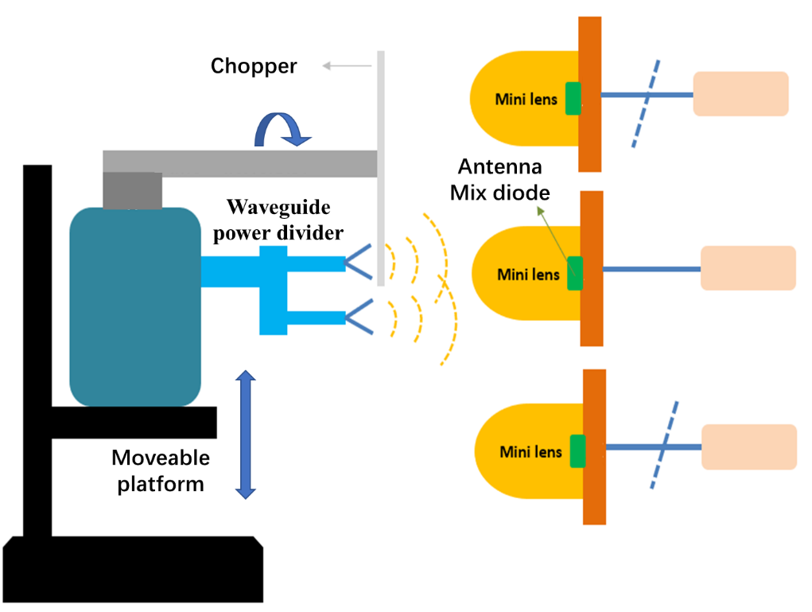

**Figure 8.** Schematic diagram of the chopper experiment setup.

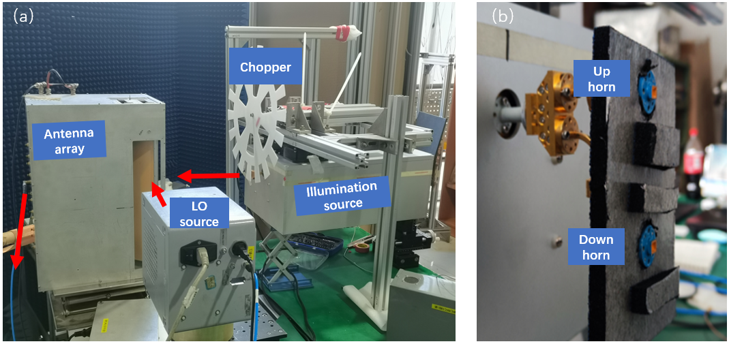

**Figure 9.** (a) table layout of the chopper experiment setup; (b) the waveguide power divider used to introduce space echo effect.

* 1. Results of the chopper experiment.

First, we adjust the mobile support platform so that the geometric center of the upper waveguide port aligns with the geometric center of the Mini Lens of the antenna while shielding the lower waveguide port. This setup corresponds to an ideal scenario without spatial echoes. In this configuration, the 79.5 GHz electromagnetic wave output from the illumination source is incident on the second antenna after passing through the chopper. The antenna's local oscillator (LO) source outputs 80.19 GHz, and the mixed signal at the second antenna, at 1.29 GHz, enters the backend electronics system. The module's local oscillator provides a 1430.12 MHz LO signal. At this time, the acquisition card only collects the 120 kHz carrier signal that has passed through the chopper at the upper waveguide port. After performing FFT processing and taking the logarithm, the frequency amplitude of the 120 kHz carrier signal is 75.84 dB.

With the above setup maintained, the upper waveguide port is shielded, and the signal from the lower waveguide port is collected, resulting in a frequency amplitude of 71.30 dB for the 120 kHz carrier signal. The purpose of sequentially shielding the upper and lower waveguide ports is to obtain the amplitude ratio of the target signal to the spatial echo. The amplitude difference between the target signal and the spatial echo signal is 4.54 dB, indicating that the intensity of the target signal is approximately 2.84 times that of the spatial echo signal.

Remove the shielding from the upper and lower waveguide ports, both signals are received simultaneously by the antenna. The time sequence diagram of the disturbance phase extracted using the HHT method is shown in Figure 10(a). When the intensity of the target signal is approximately 2.84 times that of the space echo signal, the disturbance phase can be successfully extracted.

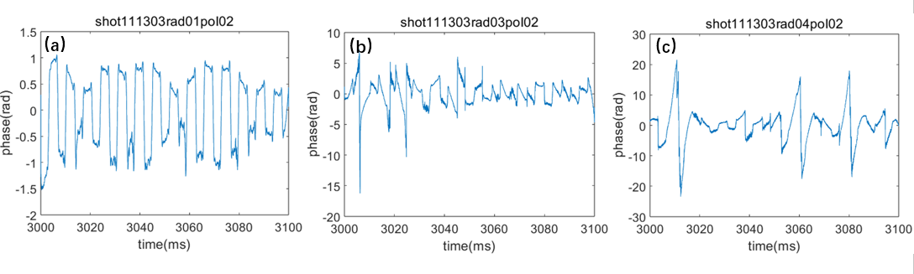

**Figure 10.** (a) The time sequence diagram of the disturbance phase when the signal-to-noise ratio is 2.84 with the introduction of spatial echoes; (b) & (c) The signal-to-noise ratios are 1.97 and 1.46 respectively.

While maintain the current frequency settings and adjust the support platform by moving the platform up by 3 cm, the amplitude difference between the target signal and the space echo signal is 2.94 dB, corresponding to a signal-to-noise ratio 1.97. The extracted time sequence diagram of the disturbance phase is shown in Figure 10 (b), indicating relatively poor periodicity in the sequence. Continuing to raise the platform by 3 cm, the intensity of the target signal is approximately 1.46 times that of the spatial echo, and the extracted time sequence of the disturbance phase is shown in Figure 10 (c). It is clearly shown that the periodic phase modulation is difficult to restore.

The chopper experiment results show that when the ratio of the effective signal amplitude reflected from the plasma to the amplitude of the space echo is less than 1.97, the HHT-based data processing method can no longer correctly extract phase disturbances. The chopper experiment confirms from an experimental perspective that it is essential to maximize the intensity of the effective signal reflected from the cutoff layer while minimizing space echos, in order to obtain high-quality MIR diagnostic data and successfully extract phase disturbances.

1. Preliminary experimental results of the MIR system on EAST.

In the first stage of MIR commissioning and operation on EAST, the system has realized the basic one-dimensional (in poloidal direction) diagnostic capability. The MIR system's illumination source emits detection wave with single frequency at 70 GHz, while the antenna's local oscillator (LO) source outputs a 74 GHz LO signal. The module's local oscillator source provides a secondary mixing LO of 4140.05 MHz. In EAST shot 141699, coherent modes with frequencies between 60 kHz ~ 70 kHz are observed in channels 3-5 of the MIR antenna array, as shown in figure 11.

**Figure 11.** Phase spectrum diagram of polodial channel 3、4、5 in EAST SHOT #141699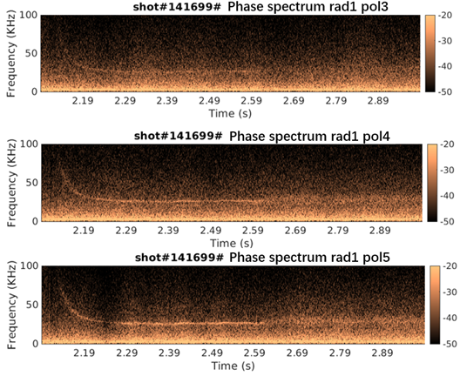.

In EAST shot 141745, the phase and amplitude spectra of the fifth antenna are shown in Figure 12. A correlation analysis was performed between the fourth and fifth antennas over a 50 ms time window from 2.3s to 2.35s during the discharge, shown in Figure 13. The analysis results indicate the presence of coherent modes with frequency range between 60 kHz and 70 kHz.

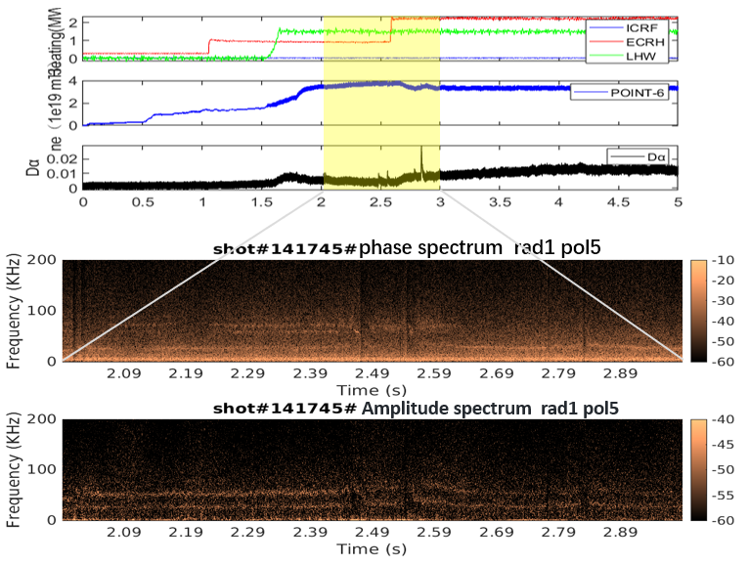

**Figure 12.** Phase and amplitude spectrum diagram of polodial channel 5 in EAST SHOT #141745.

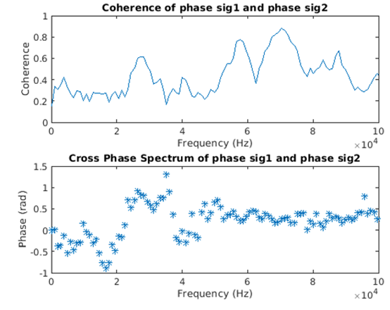

**Figure 13.** Correlation analysis between the channel 4 and 5 about EAST SHOT #141745.

1. Summary

The details of EAST MIR implementation are provided. To address the space echos encountered during the practical operation, we designed an chopper experiment in lab to find out the minimum signal-to-noise ratio required for correctly extracting the disturbance phase. Furthermore, coherent modes have been observed in the EAST boundary plasma via MIR system. The MIR tuning up is still in investigation to achieve the expected 2-D density fluctuation evolution.

Acknowledgments

This work is supported by National Magnetic Confinement Fusion Energy Program of China under Contract No. 2019YFE03020001. The authors wish to thank the EAST group for the valuable help on the engineering design.

References

[1] E. Mazzucato, *Microwave imaging reflectometry for the visualization of turbulence in tokamaks*, Nucl. Fusion 41 (2001) 2.

[2] E. Mazzucato, *Microwave reflectometry for magnetically confined plasmas*, Rev. Sci. Instrum. 69 (1998) 6.

[3] E. Mazzucato, *Numerical study of microwave reflectometry in plasmas with two-dimensional turbulent fluctuations*, Review of scientific instruments 69 (1998).

[4] R. Nazikian, C. J. Kramer, and E. Valeo, *A tutorial on the basic principles of microwave reflectometry applied to fluctuation measurements in fusion plasmas*, Phys. Plasmas, 8 (2001) 5.

[5] T. Munsat, et al., *Microwave imaging reflectometer for TEXTOR,* Review of scientific instruments 74 (2003).

[6] C. M. Muscatello, et al., *Millimeter-wave imaging reflectometry on the DIII-D Tokamak,* Nuclear Fusion (2014).

[7] R. Sabot, et al., *Development of Microwave Imaging Diagnostics for WEST Tokamak,* Journal of Fusion Energy 38 (2019).

[8] W. Lee, et al., *Microwave imaging reflectometry for KSTAR,* Journal of Instrumentation 7 (2012).

[9] S. Yamaguchi, et al., *Microwave imaging reflectometry in LHD*, Review of scientific instruments 77 (2006).

[10] Z. Shi, et al., *Development of microwave imaging reflectometry on the HL-2A tokamak*, Review of Scientific Instruments 85 (2014).

[11] Y. Zhu, et al., *Millimeter-wave imaging diagnostics systems on the EAST tokamak*, Review of Scientific Instruments 87 (2016).

[12] W. Liao, et al, *Bench test of microwave imaging reflectometry system for EAST tokamak*, Journal of Instrumentation 15 (2020).

[13] T. Munsat et al., *Laboratory characterization of an imaging reflectometer system*, Plasma Phys. Controlled Fusion 45 (2003) 4.

[14] Zhu Y, Zhao Z, Tong L, et al., *Optics system design of microwave imaging reflectometry for the EAST tokamak*, Plasma Science and Technology 18 (2016) 4.